What is Quick Sort?

Like Merge Sort, QuickSort is a Divide and Conquer algorithm. It picks an element as pivot and partitions the given array around the picked pivot. There are many different versions of quickSort that pick pivot in different ways.
- Always pick first element as pivot.
- Always pick last element as pivot (implemented below)
- Pick a random element as pivot.
- Pick median as pivot.
The key process in quickSort is partition(). Target of partitions is, given an array and an element x of array as pivot, put x at its correct position in sorted array and put all smaller elements (smaller than x) before x, and put all greater elements (greater than x) after x. All this should be done in linear time.

Approach:

Pseudo Code for recursive QuickSort function :

/* low --> Starting index, high --> Ending index */
quickSort(arr[], low, high)
{
if (low < high)
{
/* pi is partitioning index, arr[pi] is now
at right place */
pi = partition(arr, low, high);

quickSort(arr, low, pi - 1); // Before pi
quickSort(arr, pi + 1, high); // After pi
}
}
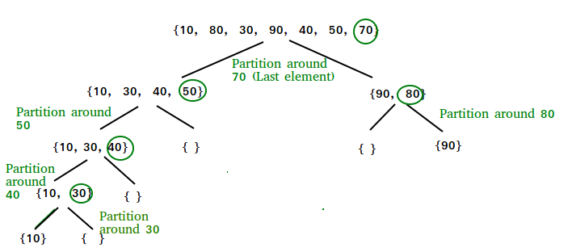Partition Algorithm
There can be many ways to do partition, following pseudo code adopts the method given in CLRS book. The logic is simple, we start from the leftmost element and keep track of index of smaller (or equal to) elements as i. While traversing, if we find a smaller element, we swap current element with arr[i]. Otherwise we ignore current element.

/* low --> Starting index, high --> Ending index */
quickSort(arr[], low, high)
{
if (low < high)
{
/* pi is partitioning index, arr[pi] is now
at right place */
pi = partition(arr, low, high);

quickSort(arr, low, pi - 1); // Before pi
quickSort(arr, pi + 1, high); // After pi
}
}
Pseudo code for partition()
/* This function takes last element as pivot, places
the pivot element at its correct position in sorted
array, and places all smaller (smaller than pivot)
to left of pivot and all greater elements to right
of pivot */
partition (arr[], low, high)
{
// pivot (Element to be placed at right position)
pivot = arr[high];

i = (low - 1) // Index of smaller element and indicates the
// right position of pivot found so far

for (j = low; j <= high- 1; j++)
{
// If current element is smaller than the pivot
if (arr[j] < pivot)
{
i++; // increment index of smaller element
swap arr[i] and arr[j]
}
}
swap arr[i + 1] and arr[high])
return (i + 1)
}
Illustration of partition() :
arr[] = {10, 80, 30, 90, 40, 50, 70}
Indexes: 0 1 2 3 4 5 6

low = 0, high = 6, pivot = arr[h] = 70
Initialize index of smaller element, i = -1

Traverse elements from j = low to high-1
j = 0 : Since arr[j] <= pivot, do i++ and swap(arr[i], arr[j])
i = 0
arr[] = {10, 80, 30, 90, 40, 50, 70} // No change as i and j
// are same

j = 1 : Since arr[j] > pivot, do nothing
// No change in i and arr[]

j = 2 : Since arr[j] <= pivot, do i++ and swap(arr[i], arr[j])
i = 1
arr[] = {10, 30, 80, 90, 40, 50, 70} // We swap 80 and 30

j = 3 : Since arr[j] > pivot, do nothing
// No change in i and arr[]

j = 4 : Since arr[j] <= pivot, do i++ and swap(arr[i], arr[j])
i = 2
arr[] = {10, 30, 40, 90, 80, 50, 70} // 80 and 40 Swapped
j = 5 : Since arr[j] <= pivot, do i++ and swap arr[i] with arr[j]
i = 3
arr[] = {10, 30, 40, 50, 80, 90, 70} // 90 and 50 Swapped

We come out of loop because j is now equal to high-1.
Finally we place pivot at correct position by swapping
arr[i+1] and arr[high] (or pivot)
arr[] = {10, 30, 40, 50, 70, 90, 80} // 80 and 70 Swapped

Now 70 is at its correct place. All elements smaller than
70 are before it and all elements greater than 70 are after
it.

Analysis

Time Complexity:

Best Case: When the partitioning happens always in the middle, then the recursion tree or Euler tree that we get is a balanced binary tree. The height of a balanced binary tree is O(log₂n). Since we are partitioning at every level, partitioning takes O(n) time, so, the best case time complexity becomes O(n X log₂n) as partitioning time is O(n) and we are doing it for O(log₂n).
Interesting Fact: For the best case of quicksort, we want the partitioning to happen always in the middle. This can only be achieved if the element we are selecting as the pivot is always the median in the remaining part of the array. But, we cannot find the median until we have a sorted list. So, there is no way we can achieve the best case every time. It just depends on the order of elements in the input.
Worst Case: Have a look at the diagram given below:
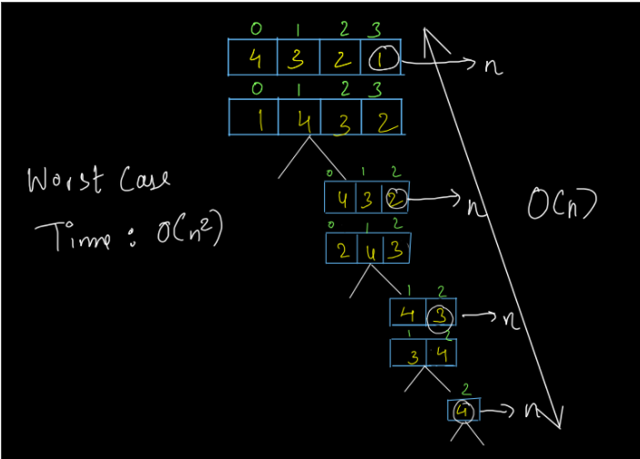
The above diagram shows the worst-case time of quicksort. When the elements are sorted in the reverse order, we obtain a right-skewed binary tree whose height is of order O(n). Since partitioning is taking place at every level and it takes O(n) time, the total time complexity becomes O(n X n) i.e. O(n²).
Interesting Fact: The worst-case time of quicksort is when we get a sorted list. If the list is sorted in the correct order, we get a left-skewed binary tree, else if it is sorted in reverse order, we get a right-skewed binary tree. Both of them are of height O(n) so, the time complexity for the worst-case becomes O(n²).
Average Case: We know that if the tree is not left or right-skewed then on average the height of a tree is O(log₂n). So, the average case time of quicksort is also O(n X log₂n).

Space Complexity:

Since we have not used any extra space, the space complexity of the above solution is O(1).

